1. Login to the developer site <https://developer.servicenow.com>

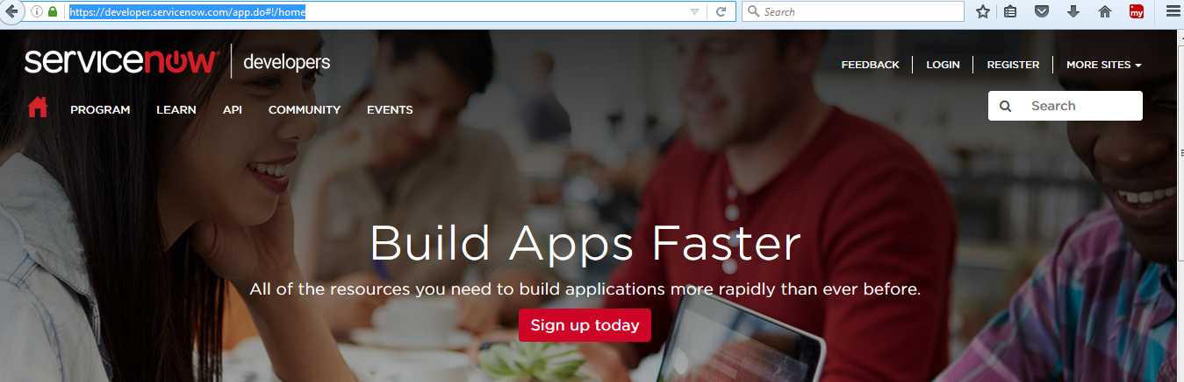

1. Register your account

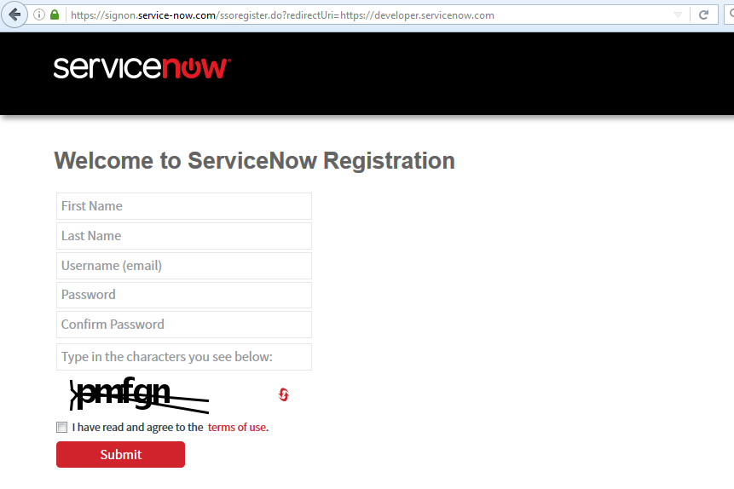

1. Once you registered account will be created for you, login this site using those credentials

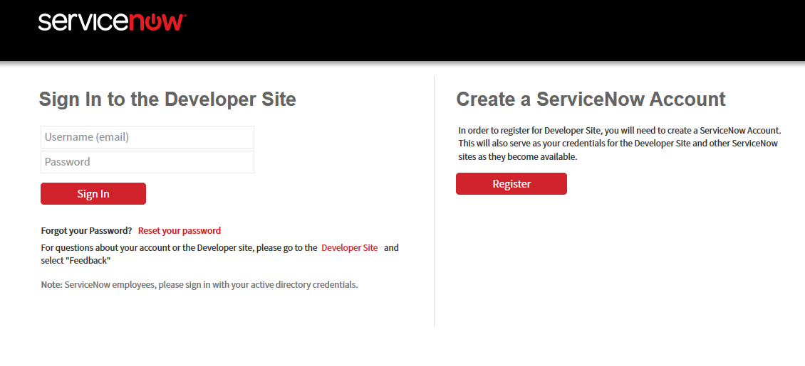

1. Once you logged in request your instance

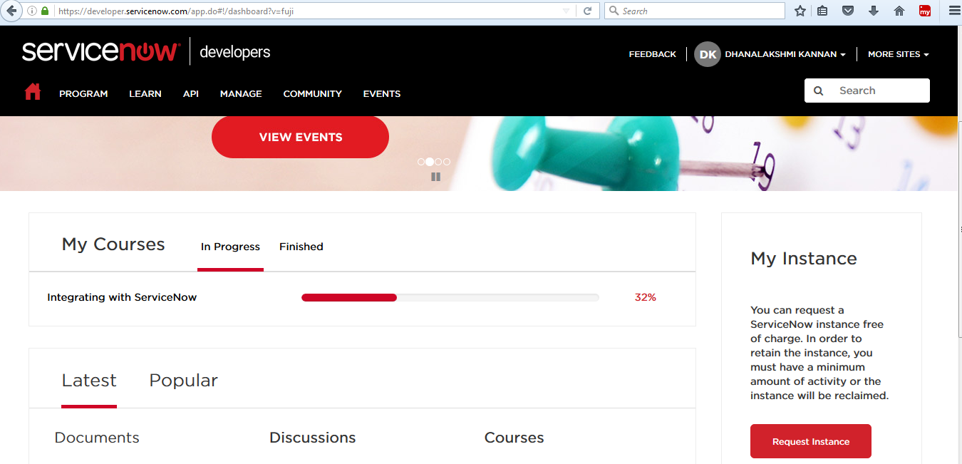

1. If any release option asked select any option and proceed, better try with fuji

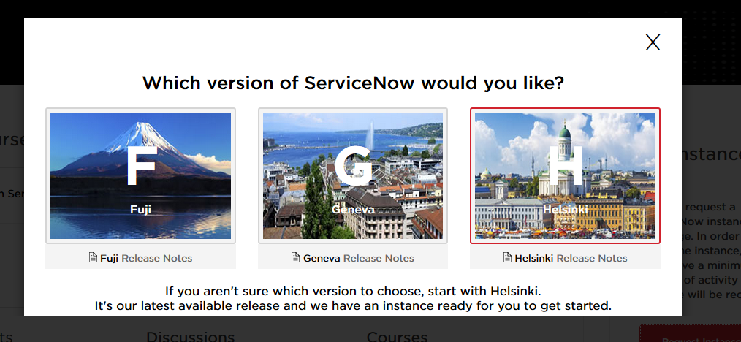

1. Instance will allocated with default user id and password will be given, using that login and reset your password than start use your instance

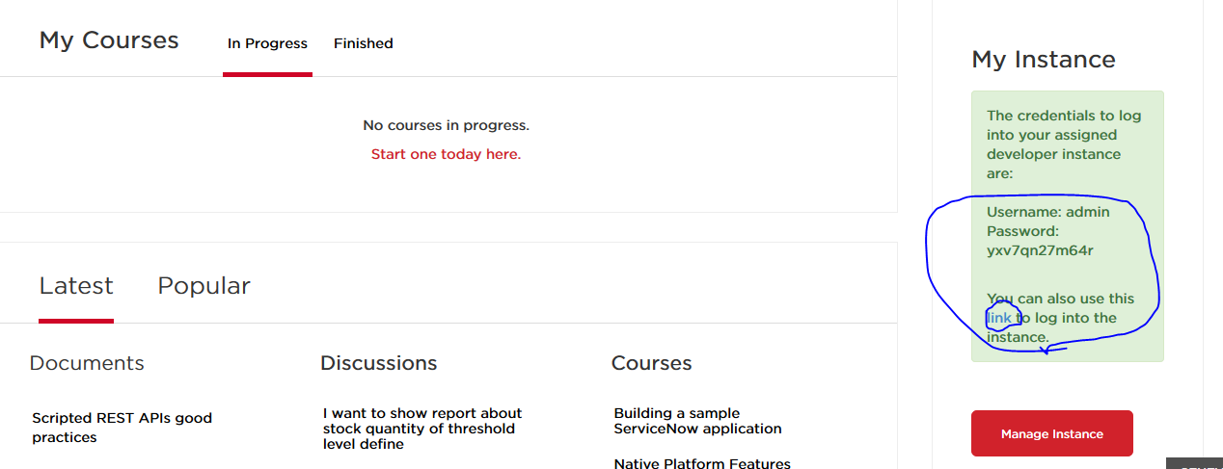

1. Instance will be created and reset your user id password and use that instance for your practice

